**Documentation**

Input Format:-

Number X, Y

number of register N

Enter number 1: X

Enter number 2: Y

Number of registers: N

Range of X, Y ∈ [-(2^(N-1)) to 2^(N-1)-1)]

Output Format:-

N line printed one by one showing values after each step.

Followed by Answer in numerical value.

Format of these lines:-

Accumulator value [space] Qn register value [space] Qn-1 register value

Final answer printed as:-

Sign [space] numerical value

Error Handling:-

There is only one error i.e. “Input value out of range”

Error is printed as “Input value out of range”

Followed by:-

Values must lie between -(2^(N-1)) to 2^(N-1)-1

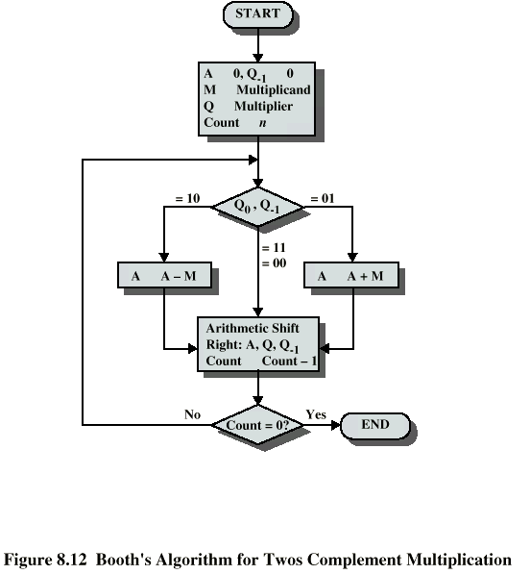

[Image src](https://cnx.org/contents/ZxCI0OEL@1/Booth-s-Algorithm)